**RENT A CAR**

**Introduction:**

**Rent a car** is a web based search system that helps the users to search the latest available cars on the website. At its most basic level, it is an online course with a series of online resources to help users for their interested cars. Basically, this service is the realization of the concept of flexible searching, by giving the user time, resources and scope to search at his/her own interest and potential. Using this website, the system can ensure the secure information traversal between the users of their system. The information of different cars is available for all the users; they can search for different cars available in this site. But, only registered users can book or rent a car.

Here, the users of the system will be registered by the admin and will be given with unique username and password, using which the users of the organization can logon ,thus the security is provided by ensuring only authenticated users logon into this website, also the security is provided for the information with help of few encrypted techniques, which ensures secure data transfer over the web or in this system, also by ensuring the information will not be exposed in between to the unauthorized users as it will be in an encrypted format, which will also be decrypted by the indented users or authenticated users of the website. An individual will select a car and go through the rent of the car as per the required period of time and book a car for rental purpose.

**Purpose:**

Purpose of developing this project is to provide flexible search for different cars to rent them, with the requirements and potential of a person.

**Scope**

By using this rent a car application, during the search or information taken from the user the information will be preserved and can be viewed only by the authenticated.

**Steps to develop and deploy the application:**

* Visual Studio 2013 was used to create and compile all data into a single project.
* Once all pages had been created and connections made to navigate from one page to the next, specific implementation of requirements was started.
* General design was established with a basic flow of pages described along with basic information needed/tracked on each page.
* HTML and ASP elements were analyzed to evaluate which best fit the needs of the page at the time of execution.

**Output Screens**

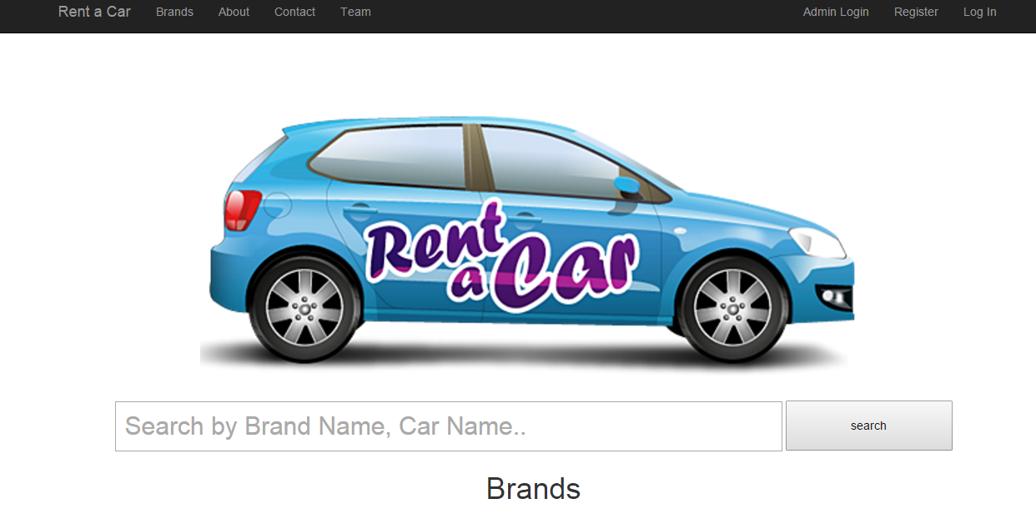**Home Screen**

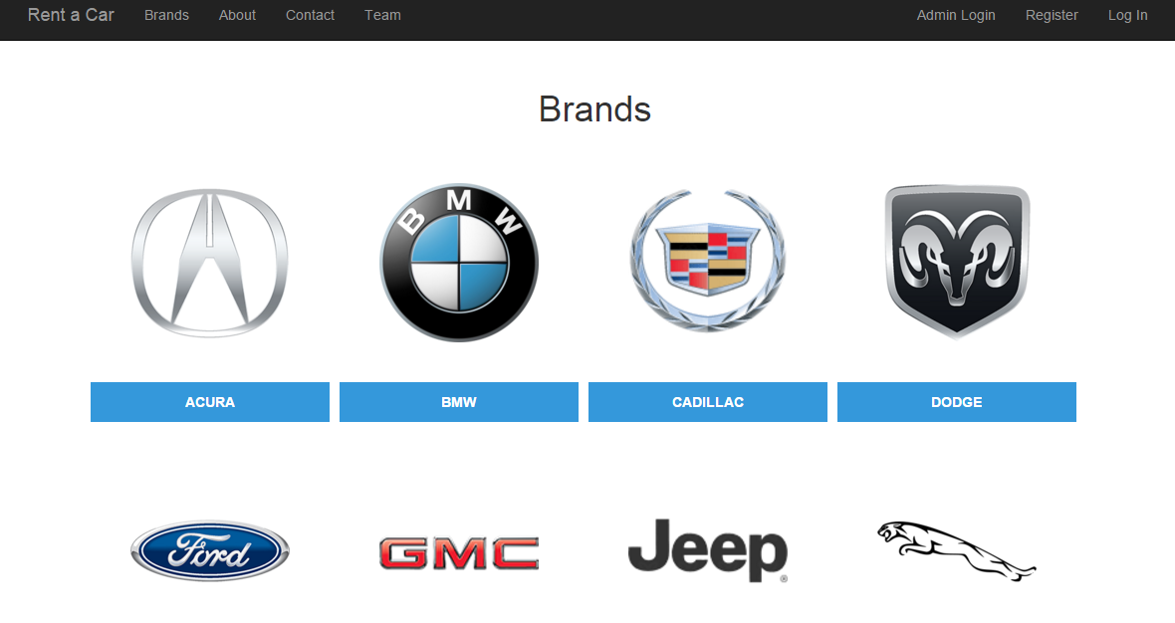

**Brands Page**

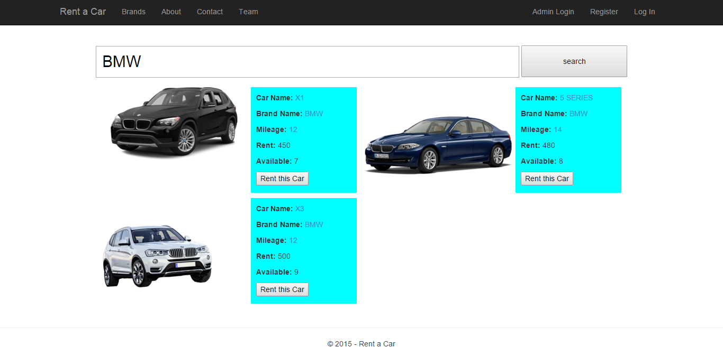

**Search Page**

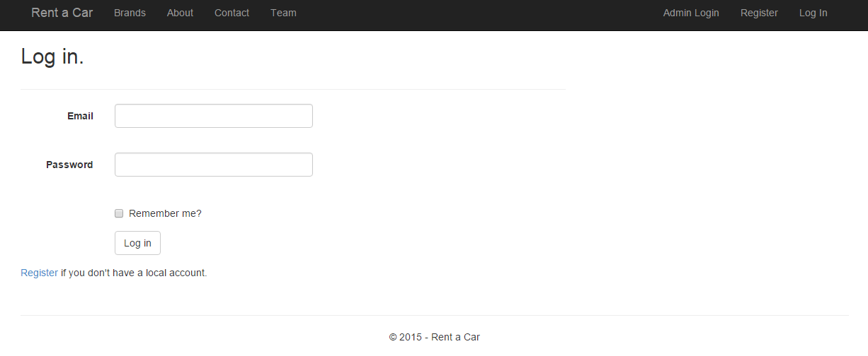

**Login Screen**

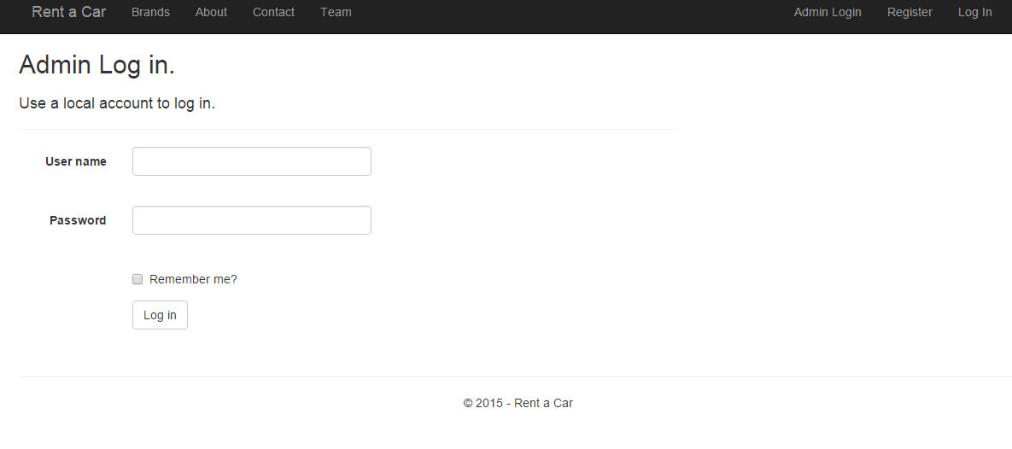

**Admin Login Page**

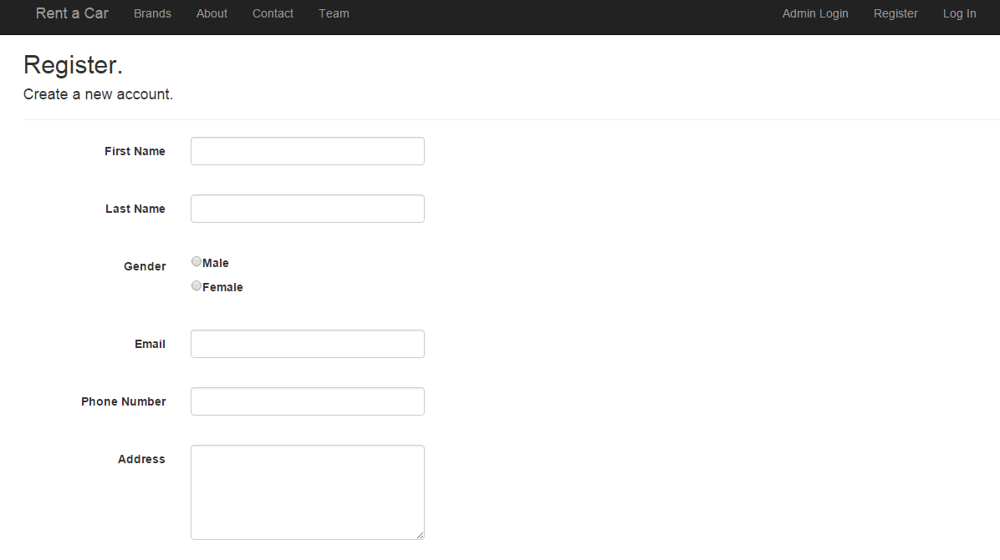

**Register Page**

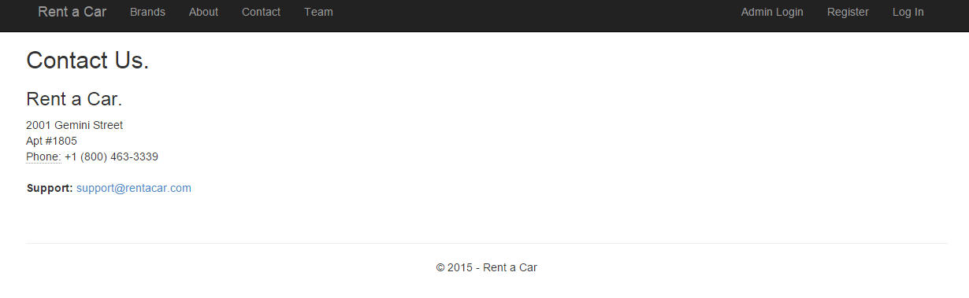

**Contact Us**

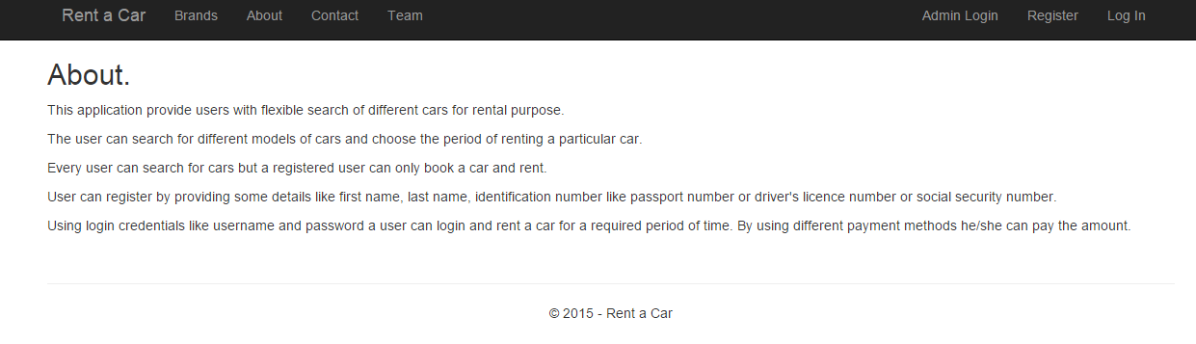

**About us**

**Conclusion:**

The main aim or objective of this application is to provide flexible search of different cars for rental purpose. This rental period may vary according to the user requirements. The rental amount for different cars will change according to the brand of car and period for renting a car.

This application fulfils the need of a user in providing the refine search of different cars for different rental periods.